#
# 20200623
# To disable notification at 2 a.m. tomorrow.

[root@vm-vol-nag4-prod ~]# yum install at
[root@vm-vol-nag4-prod ~]# at 2:00 tomorrow <<< 'echo "[`date +%s`] DISABLE_NOTIFICATIONS" > /usr/local/nagios/var/rw/nagios.cmd'
job 1 at 2020-06-24 02:00
Can't open /var/run/atd.pid to signal atd. No atd running?
[root@vm-vol-nag4-prod ~]# service atd status
atd is stopped
You have new mail in /var/spool/mail/root
[root@vm-vol-nag4-prod ~]# service atd start
Starting atd: [ OK ]
[root@vm-vol-nag4-prod ~]# chkconfig --list atd
atd 0:off 1:off 2:off 3:on 4:on 5:on 6:off
[root@vm-vol-nag4-prod ~]# atq
1 2020-06-24 02:00 a root
[root@vm-vol-nag4-prod ~]#

[root@vm-vol-nag4-prod ~]# at -c 1
#!/bin/sh
...
echo "[`date +%s`] DISABLE_NOTIFICATIONS" > /usr/local/nagios/var/rw/nagios.cmd
...
[root@vm-vol-nag4-prod ~]#

# It’s for example.
[root@vm-vol-nag4-prod ~]# date -d "2020-06-24 02:00:00" "+%s"
1592953200
[root@vm-vol-nag4-prod ~]#

#
# 20190620
#

[root@vm-vol-nag4-prod ~]# echo "[`date +%s`] DISABLE_NOTIFICATIONS" > /usr/local/nagios/var/rw/nagios.cmd
[root@vm-vol-nag4-prod ~]# echo "[`date +%s`] ENABLE_NOTIFICATIONS" > /usr/local/nagios/var/rw/nagios.cmd
[root@vm-vol-nag4-prod ~]#

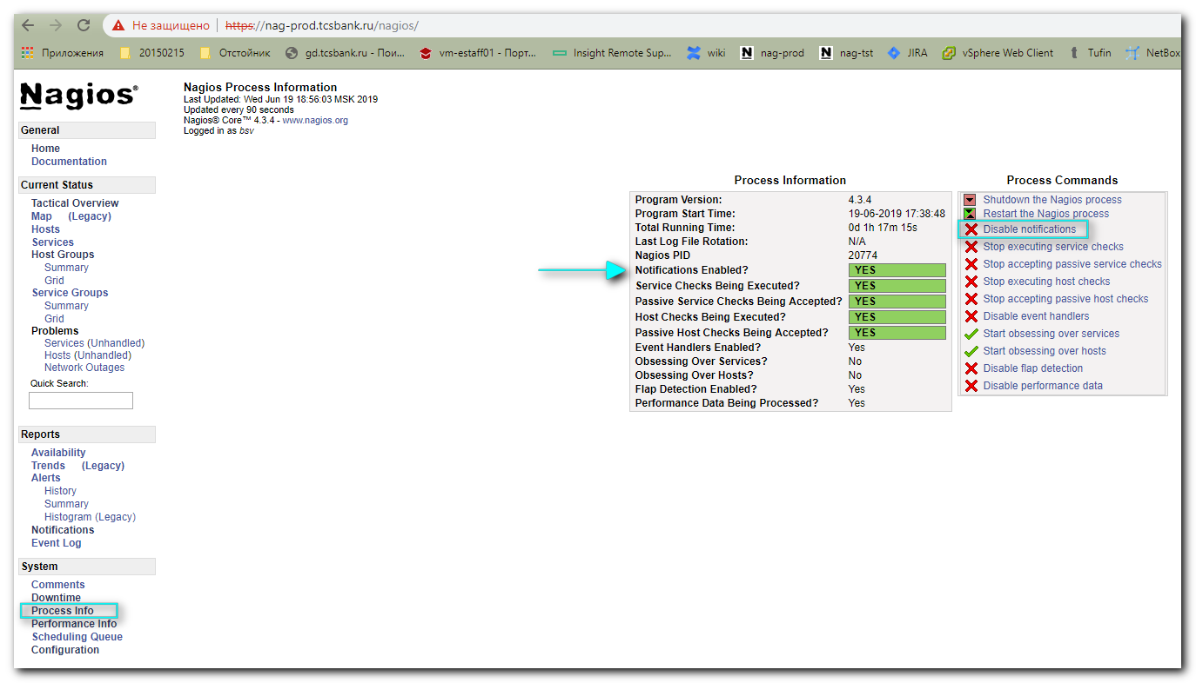

[root@vm-vol-nag4-prod ~]# find /usr/local/nagios/ -name nagios.cmd
/usr/local/nagios/var/rw/nagios.cmd
[root@vm-vol-nag4-prod ~]#

[root@vm-vol-nag4-prod ~]# echo "[`date +%s`] DISABLE_NOTIFICATIONS"
[1560959659] DISABLE_NOTIFICATIONS
[root@vm-vol-nag4-prod ~]#

[root@vm-vol-nag4-prod ~]# now=`date +%s` ; printf "[%lu] DISABLE_NOTIFICATIONS\n" $now
[1560960111] DISABLE_NOTIFICATIONS
[root@vm-vol-nag4-prod ~]#

https://serverfault.com/questions/549603/how-to-stop-disable-nagios-email-notifications

in nagios.cfg, set enable_notifications=0 and restart nagios

You can also do this via NAGIOS's command_file named pipe, if you have that defined. The advantages of doing it this way are it's internal to NAGIOS, it can be programmed from at or cron rather than requiring interaction with a web browser, and it doesn't require changing any of the config files.

To disable notifications (on CentOS6 EPEL NAGIOS - other distributions may have the command_file configured elsewhere):

echo "[`date +%s`] DISABLE_NOTIFICATIONS" > /var/nagios/rw/nagios.cmd
and to re-enable it later:

echo "[`date +%s`] ENABLE_NOTIFICATIONS" > /var/nagios/rw/nagios.cmd

You can also stop your mail server (service postfix stop) on the Nagios server, if you are relaying through the mail server on localhost where Nagios is installed. Then you can do postsuper -d ALL to delete all mails sitting in mailq.

https://assets.nagios.com/downloads/nagioscore/docs/externalcmds/cmdinfo.php?command_id=68&_ga=2.148725044.209475761.1560959016-358331689.1539856107

Nagios Core External Commands
< Back to external commands list

STOP_EXECUTING_HOST_CHECKS

Command Format:
STOP_EXECUTING_HOST_CHECKS

Description:
Disables active host checks on a program-wide basis.

Shell Script Usage Example:
#!/bin/sh
# This is a sample shell script showing how you can submit the STOP_EXECUTING_HOST_CHECKS command
# to Nagios. Adjust variables to fit your environment as necessary.

now=`date +%s`
commandfile='/usr/local/nagios/var/rw/nagios.cmd'

/bin/printf "[%lu] STOP_EXECUTING_HOST_CHECKS\n" $now > $commandfile

Command Categories:
Hosts
Nagios Process
Service and Host Checks

Nagios Version(s):
2.x, 3.x, 4.x

